**Calculator Assumed**

**Linear and Quadratic Equations and Functions**

Time: 45 minutes

Total Marks: 45

Your Score: / 45



**Question One: [2, 2, 2 = 6 marks]**

Consider the function .

1. Which of these functions are parallel to ?

Circle or highlight all solutions.

 

 

1. Which of these functions have the same vertical intercept as ?

Circle or highlight all solutions.

 

 

1. Which of these functions have the same horizontal intercept as ?

Circle or highlight all solutions.

 

 

**Question Two: [3, 1, 2, 2 = 9 marks]**

The supply of *S* units of a particular product is given by  where *x* is the number of days since production recommenced after a cease in production.

The demand for *D* units of this particular product is given by .

1. Sketch each of these functions on the axes below.

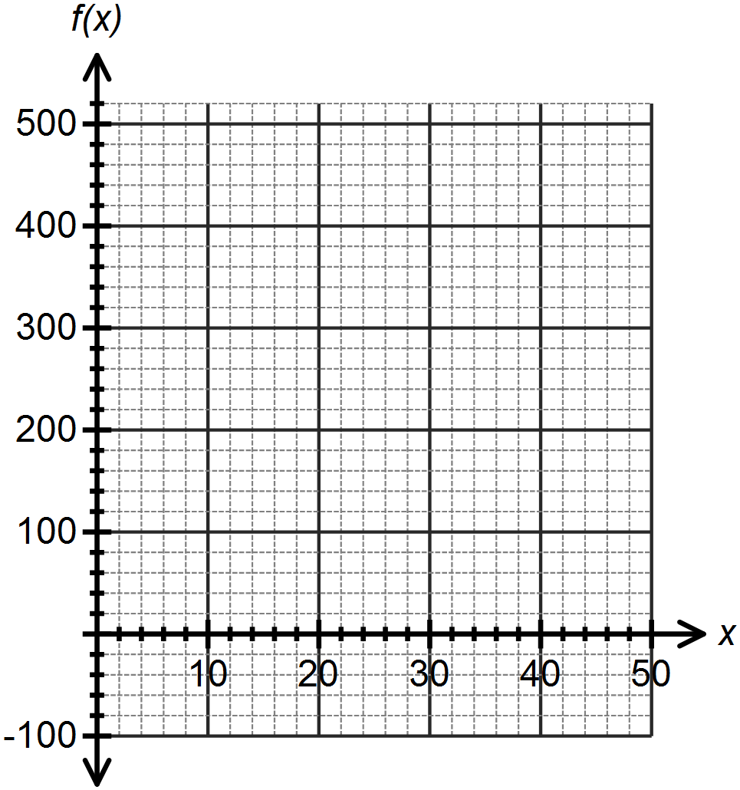

Use your graph to answer the following questions, correct to 2 decimal places:

1. After how many days does demand meet supply the first time?
2. For how many days does business “look good”, that is, demand is greater than supply?
3. After how many days should the company look into a new advertising campaign? Justify your answer.

**Question Three: [4, 3 = 7 marks]**

1. On the axes below sketch the function , showing all intercepts and turning points.

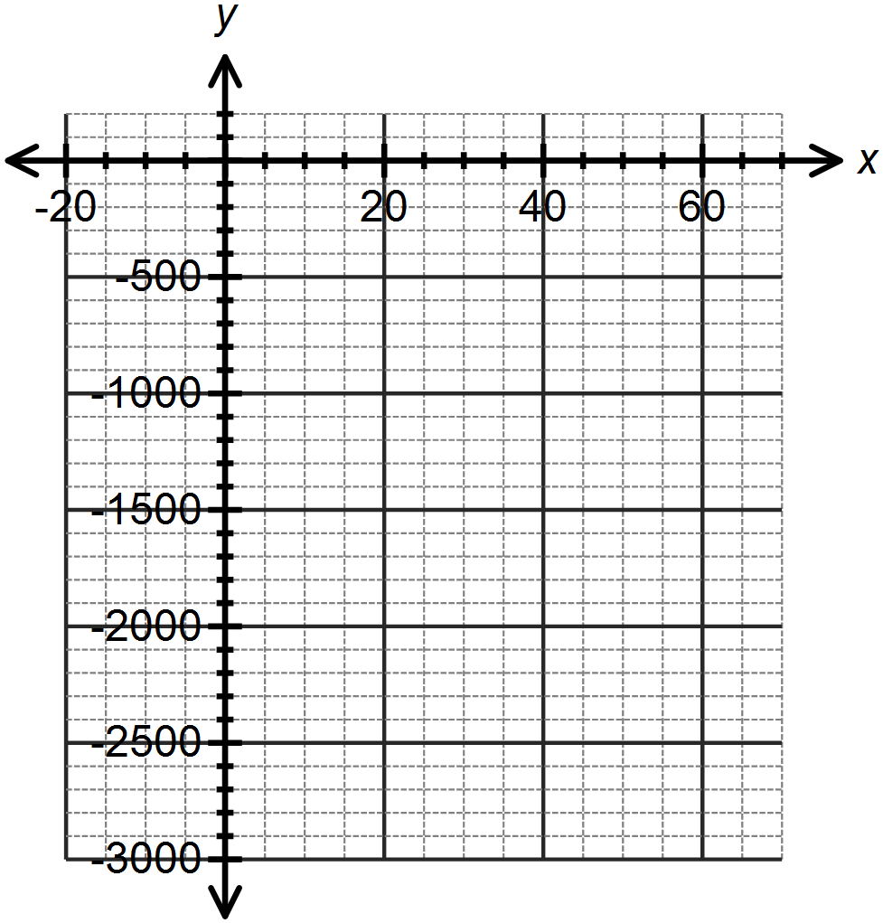

1. Hence or otherwise transform the equation of the function into the form 

**Question Four: [3, 2 = 5 marks]**

There are three children in a family. The eldest is twice the age of the youngest. The middle child is 3 years younger than the eldest. The sum of their ages is 47 years. Let *x* represent the age of the youngest child.

1. Write an equation in one variable to represent this situation.
2. Determine the age of each child.

**Question Five: [3, 2 = 5 marks]**

The area of a right triangle is .

The base is 3cm less than the height.

1. Write an equation in one variable to represent this situation.
2. Determine the dimensions of the triangle.

**Question Six: [3, 1 = 4 marks]**

1. Explain, with reference to the discriminant in the quadratic formula, why the function has only one root.
2. From your answer in part (a), what can you say about the turning point of this function?

**Question Seven: [3, 3 = 6 marks]**

Determine the equation of each of the functions drawn below.

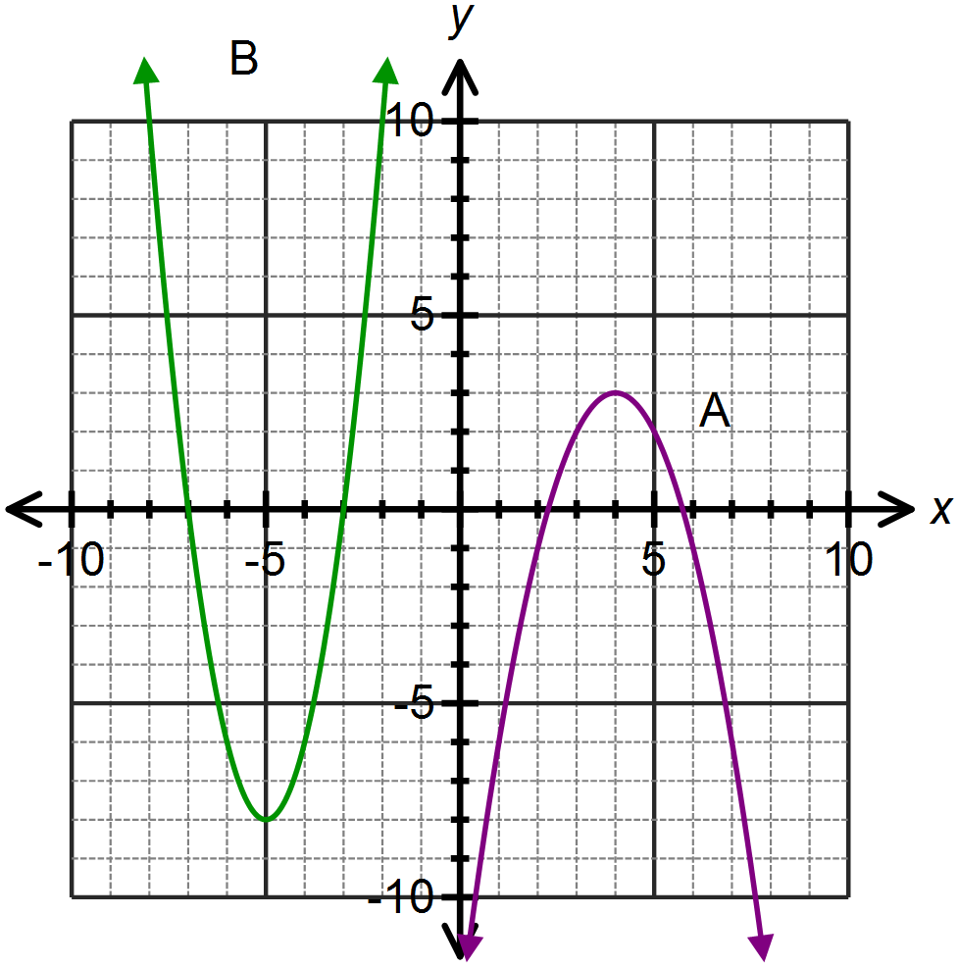

A:

B:

**Question Eight: [3 marks]**

Isabel throws a ball for her dog to catch. The path of the ball is parabolic and can be modeled by the equation  where *h* is the height in metres of the ball above the ground and *x* is the horizontal distance of the ball from Isabel.

If Isabel’s dog is 4m away from her, how far does he have to jump to catch the ball?

Provide a sketch to illustrate your answer.

**SOLUTIONS**

**Calculator Assumed**

**Linear and Quadratic Equations and Functions**

Time: 45 minutes

Total Marks: 45

Your Score: / 45



**Question One: [2, 2, 2 = 6 marks]**

Consider the function .

1. Which of these functions are parallel to ?

Circle or highlight all solutions.

 

 

1. Which of these functions have the same vertical intercept as ?

Circle or highlight all solutions.

 

 

1. Which of these functions have the same horizontal intercept as ?

Circle or highlight all solutions.

 

 

**Question Two: [3, 1, 2, 2 = 9 marks]**

The supply of *S* units of a particular product is given by  where *x* is the number of days since production recommenced after a cease in production.

The demand for *D* units of this particular product is given by .

1. Sketch each of these functions on the axes below.

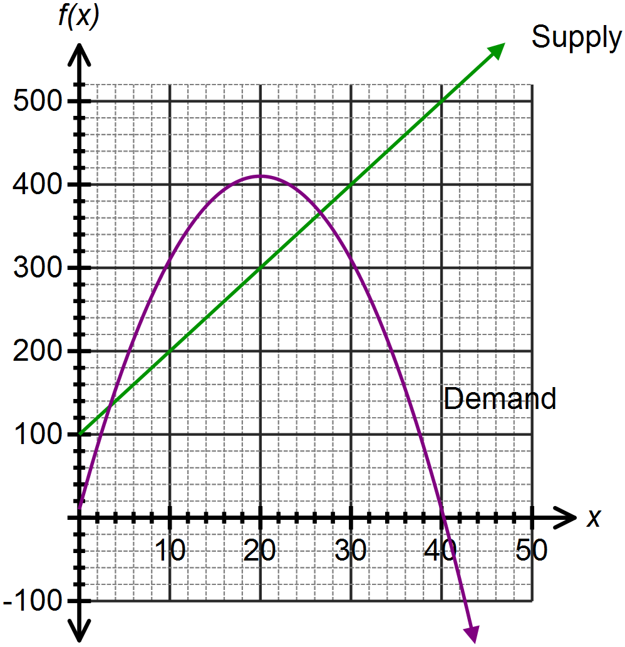



Use your graph to answer the following questions, correct to 2 decimal places:

1. After how many days does demand meet supply the first time?

3.38 days

1. For how many days does business “look good”, that is, demand is greater than supply?

26.62 – 3.38 = 23.24 $∴$ 23 days

1. After how many days should the company look into a new advertising campaign? Justify your answer.

After 26.62 days. This is when demand starts to fall below supply.

**Question Three: [4, 3 = 7 marks]**

1. On the axes below sketch the function , showing all intercepts and turning points.

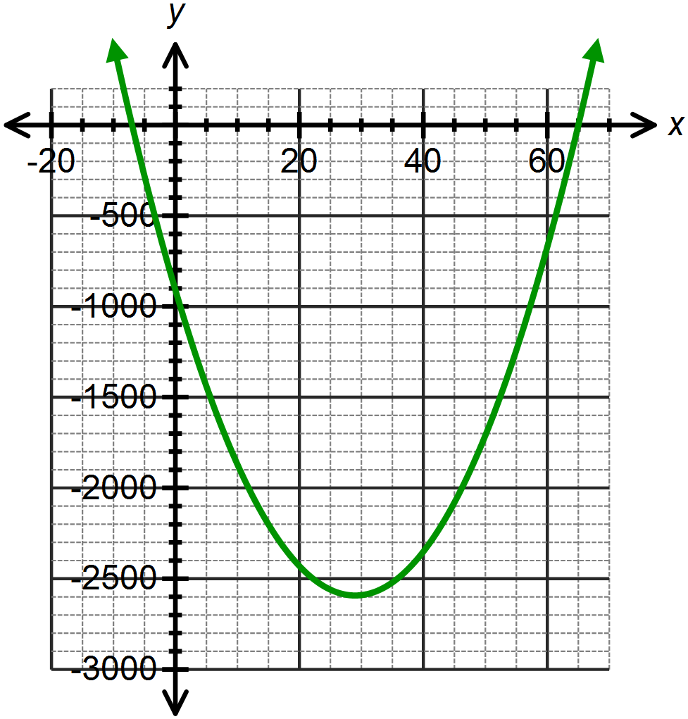







1. Hence or otherwise transform the equation of the function into the form 



**Question Four: [3, 2 = 5 marks]**

There are three children in a family. The eldest is twice the age of the youngest. The middle child is 3 years younger than the eldest. The sum of their ages is 47 years. Let *x* represent the age of the youngest child.

1. Write an equation in one variable to represent this situation.



1. Determine the age of each child.



Youngest is 10 years old

Middle child is 17 years old

Eldest child is 20 years old.

**Question Five: [3, 2 = 5 marks]**

The area of a right triangle is .

The base is 3cm less than the height.

1. Write an equation in one variable to represent this situation.



1. Determine the dimensions of the triangle.



The base is 5 cm and the height is 8 cm.

**Question Six: [3, 1 = 4 marks]**

1. Explain, with reference to the discriminant in the quadratic formula, why the function has only one root.



Since the discriminant is zero, there is only one root.

1. From your answer in part (a), what can you say about the turning point of this function?

The turning point is on the *x* – axis.

**Question Seven: [3, 3 = 6 marks]**

Determine the equation of each of the functions drawn below.





A: 

B:

Or 

**Question Eight: [3 marks]**

Isabel throws a ball for her dog to catch. The path of the ball is parabolic and can be modeled by the equation  where *h* is the height in metres of the ball above the ground and *x* is the horizontal distance of the ball from Isabel.

If Isabel’s dog is 4m away from her, how far does he have to jump to catch the ball?

Provide a sketch to illustrate your answer.

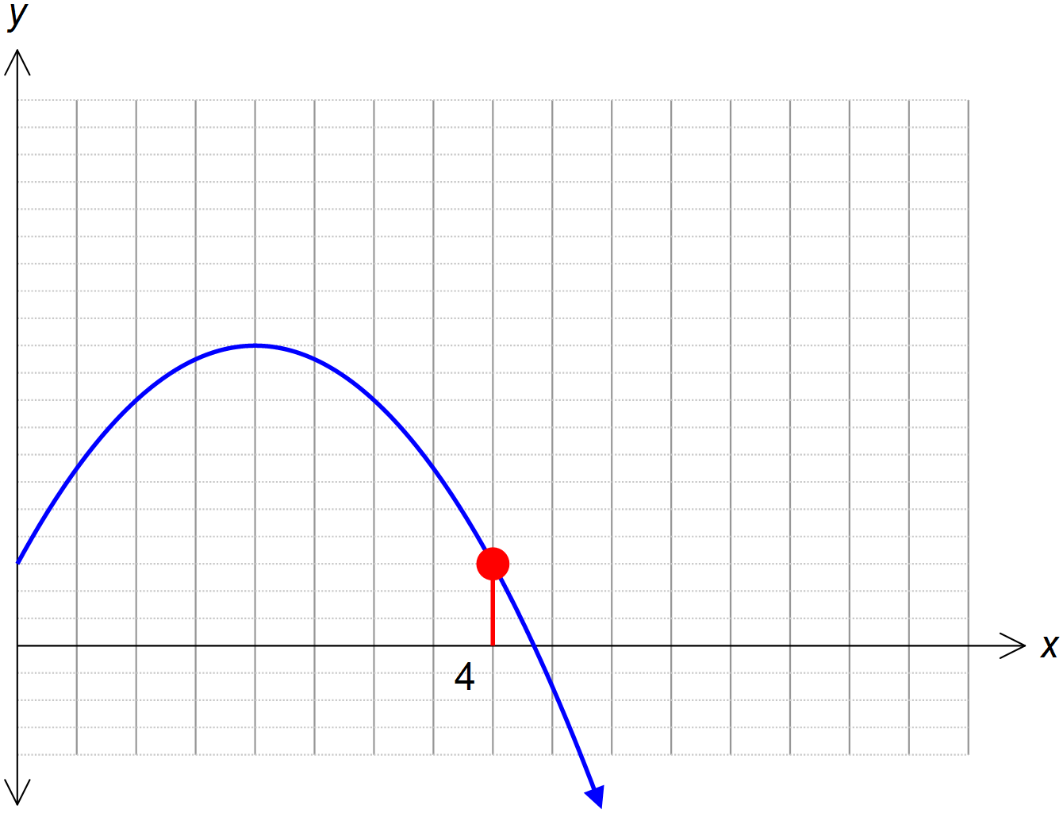







The dog has to jump 1.5m to catch the ball.